Report on and Analysis of

Main Street and Walnut Drive ATC Survey
Conducted
09 to 15 December 2023
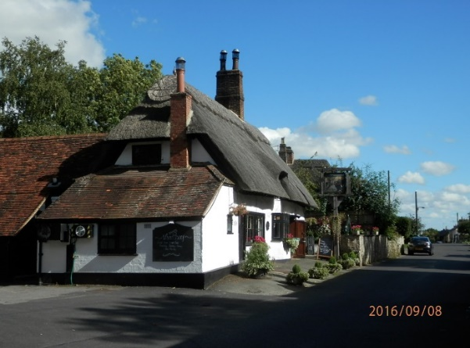
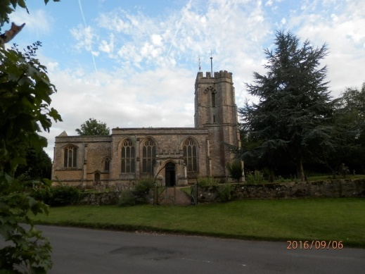
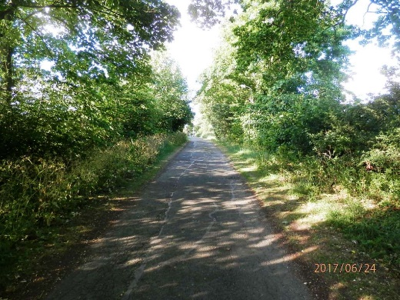
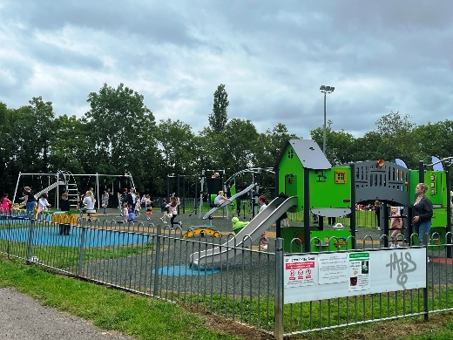

Pat Hardcastle for Maids Moreton Parish Council

With support from Malcolm and Rebecca Sayers

Table of Contents
Acknowledgements 2
1 Background 3
2 Location of the ATCs 3
3 Traffic flow volume and timing 4
4 Vehicle speeds 7
5 Comparison of traffic flow figures with earlier counts 8
Annex 1. Location of ATCs 9
Annex 2. Weekday and weekend speed – Main St 10
Annex 3. HGV detailed hourly flow on Main St and Walnut Drive 12

Table 1 Traffic volume and vehicle type 4
Figure 1 Average Weekday Hourly Traffic Flow -- Main St 4
Figure 2 Average Weekday Hourly Traffic Flow -- Walnut Dr 5
Table 2 Summary of Weekday and Weekend HGV hourly flow 6
Table 3 Vehicle speed summary 7
Figure 3 Vehicle speeds on Main St 7
Table 4 Main St hourly traffic flow survey results 8
Figure 4 ATC Location on Walnut Drive 9
Figure 5 ATC Location on Main Steet 9
Table 5 Vehicle numbers in speed bands - weekdays 10
Table 6 Vehicle numbers in speed bands – weekends 11
Table 7 HGVs Main St Northbound 12
Table 8 HGVs Main St Southbound 13
Table 9 HGVs Walnut Dr Eastbound 14
Table 10 HGVs Walnut Dr Westbound 15

Acknowledgements
James McGavin of The Transportation Consultancy Ltd kindly provided names and contact details for two companies that could undertake at short notice a small ATC survey for us and John Burton of Auto Surveys Ltd. was contracted to do this on Thursday 7 December. He very efficiently put the equipment in place the following day providing MMPC with seven days of recording from Saturday 9 to Friday 15 December inclusive.

Malcolm and Rebecca Sayers undertook the initial extraction and analysis of the ATC records to facilitate the preparation of this report.

Background
- For many years, MMPC has been concerned by the volume, type and speed of traffic using Main Street. This concern is predicated on three major aspects. Firstly, the safety of residents and visitors given that for much of its 400m length, Main Street has only one and for a substantial distance no, pavements and children have to cross it to access their schools. Secondly, the 12 listed buildings and 13 buildings of note that lie on both sides of the thoroughfare since many of the older buildings have no foundations and are very vulnerable to damage from vibration due to traffic. Thirdly, the general quality of life of for residents many of whom are elderly.
- The junction of Walnut Drive with Main Street is particularly important. The planned development of circa. 170 houses given outline approval under application 16/00151/AOP proposes to use Walnut drive as a main access point for the development. More recently, Vitalograph has submitted an application (23/03284/APP) to expand their facilities at the top of Walnut Drive. Both these applications would result in greatly increased traffic flows and the aim of this study is to provide a good baseline of current traffic in NE Main Street and Walnut Drive.

Location of the ATCs
- The ATC on Walnut Drive was placed about 7m from the white line at the junction with Main Street. The ATC on Main Street was placed about 15m SE from the centreline of Walnut Drive and 35m from the white line at the junction with Towcester Road. Photographs of the locations are provided in Annex 1.
- Going SE from the point where the Main Street ATC was located, there are no pavements on either side until the junction with The Pightle. This section passes The Wheatsheaf pub just past Old Walls while opposite The Pightle is the Village Hall. The carriageway in this section has a wall on the NE side and properties abutting it directly on the SW side. Visibility for vehicles leaving the pub car park is restricted by Old Walls towards Towcester Road and limited by the pub itself for vehicles coming up Main Street from Church Street. As there are also parked cars, one would expect traffic to be travelling appropriately slowly.

Traffic flow volume and timing
- Traffic volume and vehicle type
Date |  | Main St |  |  | Walnut Dr
 | Total | Light | Heavy | Total | Light | Heavy
Sat 9 Dec | 1099 | 1094 | 5 | 100 | 93 | 7
Sun 10 Dec | 830 | 827 | 3 | 91 | 87 | 4
Mon 11 Dec | 1604 | 1593 | 11 | 341 | 315 | 26
Tue 12 Dec | 1708 | 1697 | 11 | 328 | 297 | 31
Wed 13 Dec | 1747 | 1726 | 21 | 277 | 257 | 20
Thu 14 Dec | 1689 | 1678 | 11 | 309 | 287 | 22
Fri 15 Dec | 1663 | 1654 | 9 | 237 | 219 | 18
Average flows
Weekdays | 1682 | 1670 | 13 | 298 | 275 | 23
Weekend | 965 | 961 | 4 | 96 | 90 | 6

“Light” vehicles includes cars, small vans and pick-ups, Heavy vehicles are all others.
- Figure 1 and Figure 2 below show the average weekday hourly vehicle flow at both locations
- Average Weekday Hourly Traffic Flow -- Main St

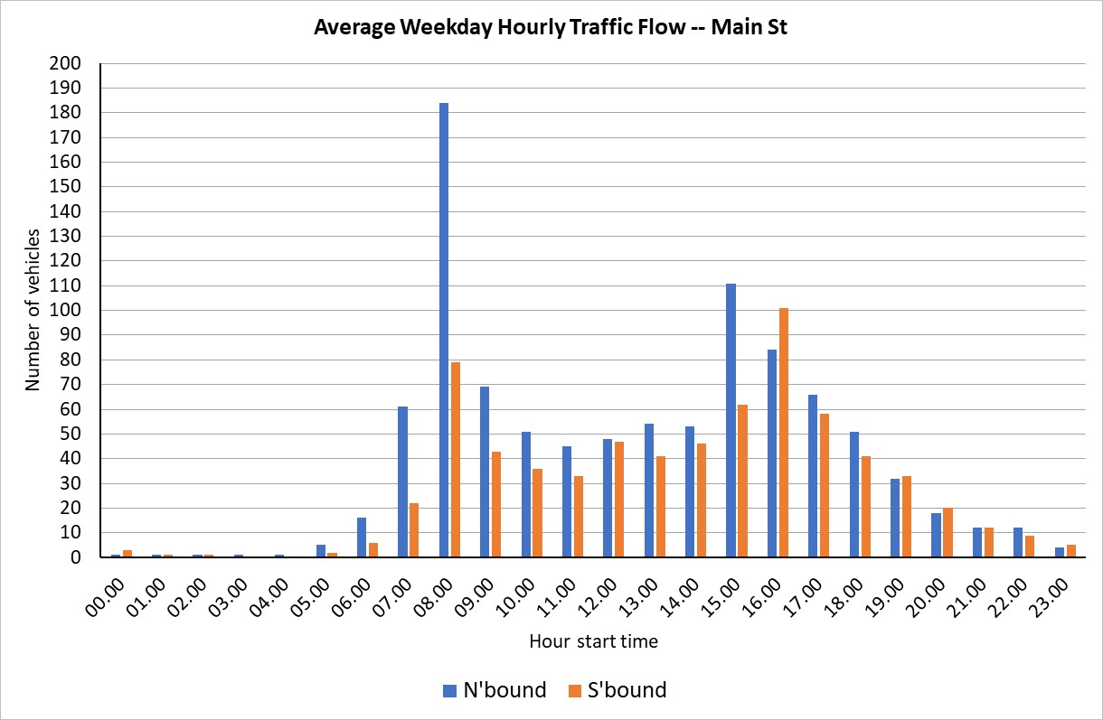

- Average Weekday Hourly Traffic Flow -- Walnut Dr

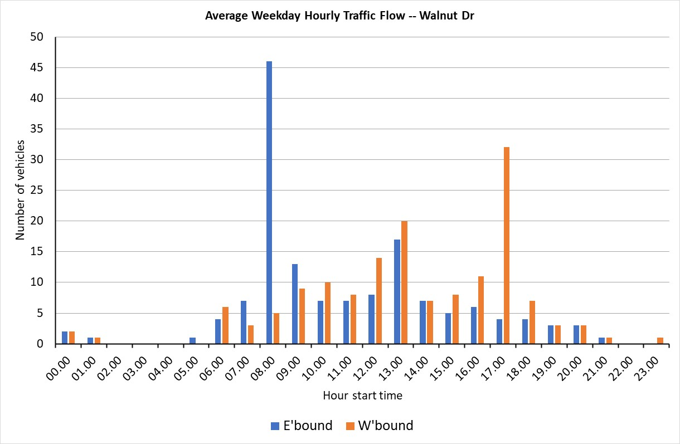

- Table 1 above categorises the vehicle flow into light and heavy vehicles, this has been extracted from the more detailed records for the two ATCs. The number of heavy vehicles recorded by the Main St ATC is concerning. Heavy vehicles using Main St for deliveries to the pub and the agricultural engineers only account for a small number of movements. This suggests that overweight vehicles are using the village as a cut-through to avoid the heavy traffic in Buckingham town centre.
- The records for Walnut Drive show, as expected, a considerable number of heavy vehicles on weekdays but also even at the weekend. Given the expected traffic flow from the Walnut Drive housing development, it appears evident that there would be a further substantial increase in both light and heavy traffic were the proposed Vitalograph development to go ahead. This would result in gross overload of the junction of Walnut Drive and Main St in addition to imposing an unacceptable disturbance on the quality of life of current residents.
- Table 2 below summarises the hourly number of HGVs on Main Street and Walnut Drive in each direction, the full details are provided in Annex 3. HGV traffic on Main Street is distributed throughout the working day but is also occurring at hours when there are pedestrians walking to and from school as well as commuting traffic. On Walnut Drive, most eastbound HGV movements occur in the morning rush hour from 0800 while westbound movements are at their peak in the evening rush hour from 1700. There are also a few HGVs moving in the very early morning on Walnut Drive.

- Summary of Weekday and Weekend HGV hourly flow
 | Main St |  |  |  | Walnut Dr
Start hour | Northbound |  | Southbound |  | Eastbound |  | Westbound
 | Wkdays | Wkend | Wkdays | Wkend | Wkdays | Wkend | Wkdays |  | Wkend
00.00 | 0 | 0 | 0 | 0 | 0 | 0 | 0 | 0
01.00 | 0 | 0 | 0 | 0 | 2 | 0 | 0 | 1
02.00 | 0 | 0 | 0 | 0 | 0 | 0 | 1 | 0
03.00 | 0 | 0 | 0 | 0 | 0 | 0 | 0 | 0
04.00 | 0 | 0 | 0 | 0 | 0 | 0 | 0 | 0
05.00 | 0 | 0 | 0 | 0 | 0 | 0 | 0 | 0
06.00 | 0 | 0 | 0 | 0 | 2 | 0 | 2 | 0
07.00 | 3 | 0 | 1 | 0 | 2 | 0 | 3 | 0
08.00 | 2 | 0 | 4 | 0 | 16 | 0 | 1 | 1
09.00 | 3 | 0 | 2 | 0 | 5 | 0 | 1 | 1
10.00 | 2 | 0 | 1 | 0 | 4 | 1 | 5 | 1
11.00 | 2 | 2 | 3 | 0 | 3 | 2 | 2 | 0
12.00 | 1 | 0 | 8 | 2 | 8 | 0 | 8 | 1
13.00 | 1 | 0 | 3 | 0 | 7 | 0 | 6 | 0
14.00 | 1 | 0 | 3 | 0 | 2 | 0 | 2 | 1
15.00 | 8 | 0 | 1 | 1 | 1 | 0 | 2 | 1
16.00 | 5 | 0 | 3 | 0 | 2 | 0 | 6 | 0
17.00 | 3 | 0 | 3 | 0 | 3 | 0 | 13 | 0
18.00 | 3 | 1 | 2 | 1 | 1 | 1 | 4 | 0
19.00 | 0 | 1 | 0 | 0 | 1 | 0 | 1 | 0
20.00 | 0 | 0 | 1 | 0 | 0 | 0 | 1 | 0
21.00 | 0 | 0 | 0 | 0 | 0 | 0 | 1 | 0
22.00 | 0 | 0 | 0 | 0 | 0 | 0 | 0 | 0
23.00 | 0 | 0 | 0 | 0 | 0 | 0 | 0 | 0
Total | 34 | 4 | 35 | 4 | 59 | 4 | 59 | 7

Vehicle speeds
- Vehicle speed summary
Location & direction |  | No. of | vehicles
Speed category | <20 | 21-<26 | 26-30 | >30 | Total
Main St Northbound | 3284 | 2171 | 469 | 41 | 5965
Main St Southbound | 2701 | 1409 | 252 | 13 | 4375
Walnut Drive Eastbound | 814 | 2 | 0 | 0 | 816
Walnut Drive Westbound | 867 | 0 | 0 | 0 | 867

- It is clearly evident that speeding is not an issue on Walnut Drive but this is not so on Main Street. Given that at the ATC point was on a narrow carriageway with no footpath on either side, solid barriers at both sides, parked cars and proximity of the Walnut Drive and Towcester Road junctions, any speed above 20mph is not compliant with the requirement to drive at a speed suitable for the road and conditions. Yet 45% of northbound and 38% of southbound traffic was exceeding 20 mph.
- Vehicle speeds on Main St
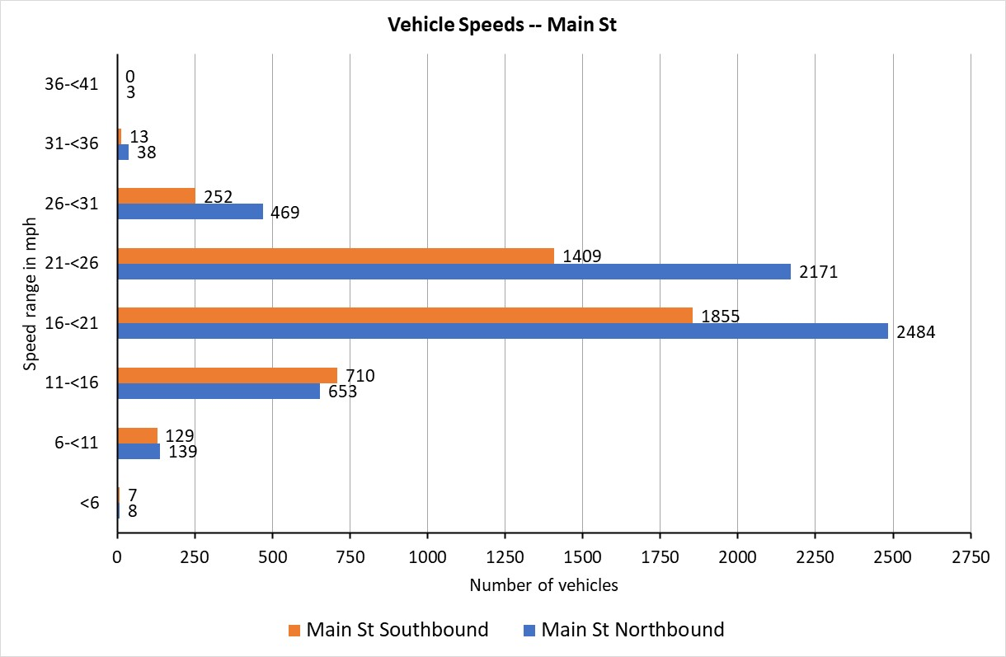

- This is where the detailed records from the ATC are very useful. Annex 2 includes a summation of the speed data to show the vehicle flows in both directions on Main Street in speed bands at each hour separated into weekdays and weekends. This shows that while relatively few vehicles exceed the current speed limit of 30 mph, a substantial number are driving at inappropriate speeds at times when Main St is also busy with foot traffic.

Comparison of traffic flow figures with earlier counts
- Table 3 includes figures from the manual counts and the October 2020 ATC records as well as the December 2023 ATC records. The manual count figures are for specific days, the ATC figures are average figures for weekdays.
- Main St hourly traffic flow survey results
Traffic Survey | Northbound | Southbound | Northbound | Southbound | Northbound | Southbound | Northbound | Southbound
Time period | 0800 - | 0900 | 1700 - | 1800 | 1600 - | 1700 | 1500 - | 1600
6 December 2018 | 148 | 73 | 69 | 72 | 103 | 118 | 100 | 69
7 November 2019 | 152 | 72 | 82 | 105
19 December 2019 | 91 | 35
14 October 2020 ^{, 4} | 132 | 55 | 60 | 56 | 60 | 73 | 86 | 63
21 October 2020 ^{, 4} | 75 | 35 | 51 | 48 | 45 | 40 | 57 | 56
28 March 2023 | 145 | 68
11 to 15 December 2023 | 184 | 79 | 66 | 58 | 84 | 101 | 111 | 62

- Location of ATCs
- ATC Location on Walnut Drive
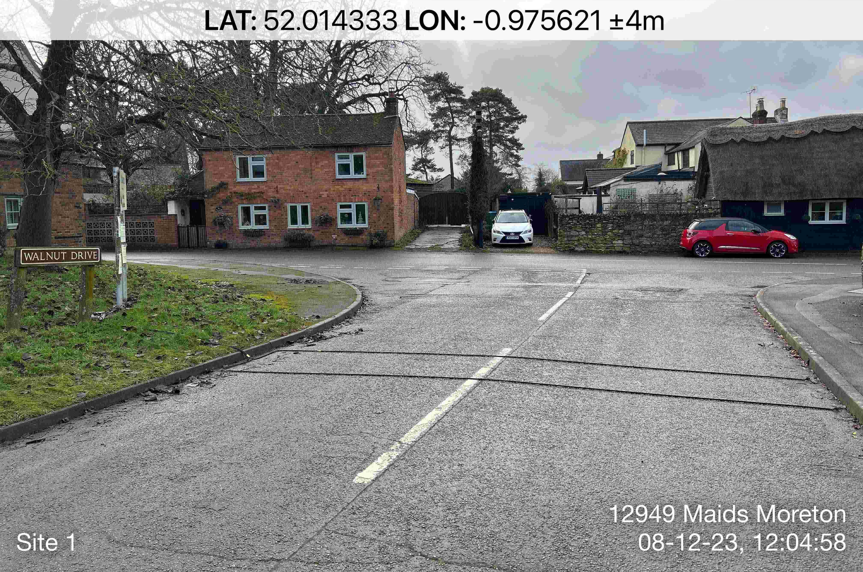

- ATC Location on Main Steet
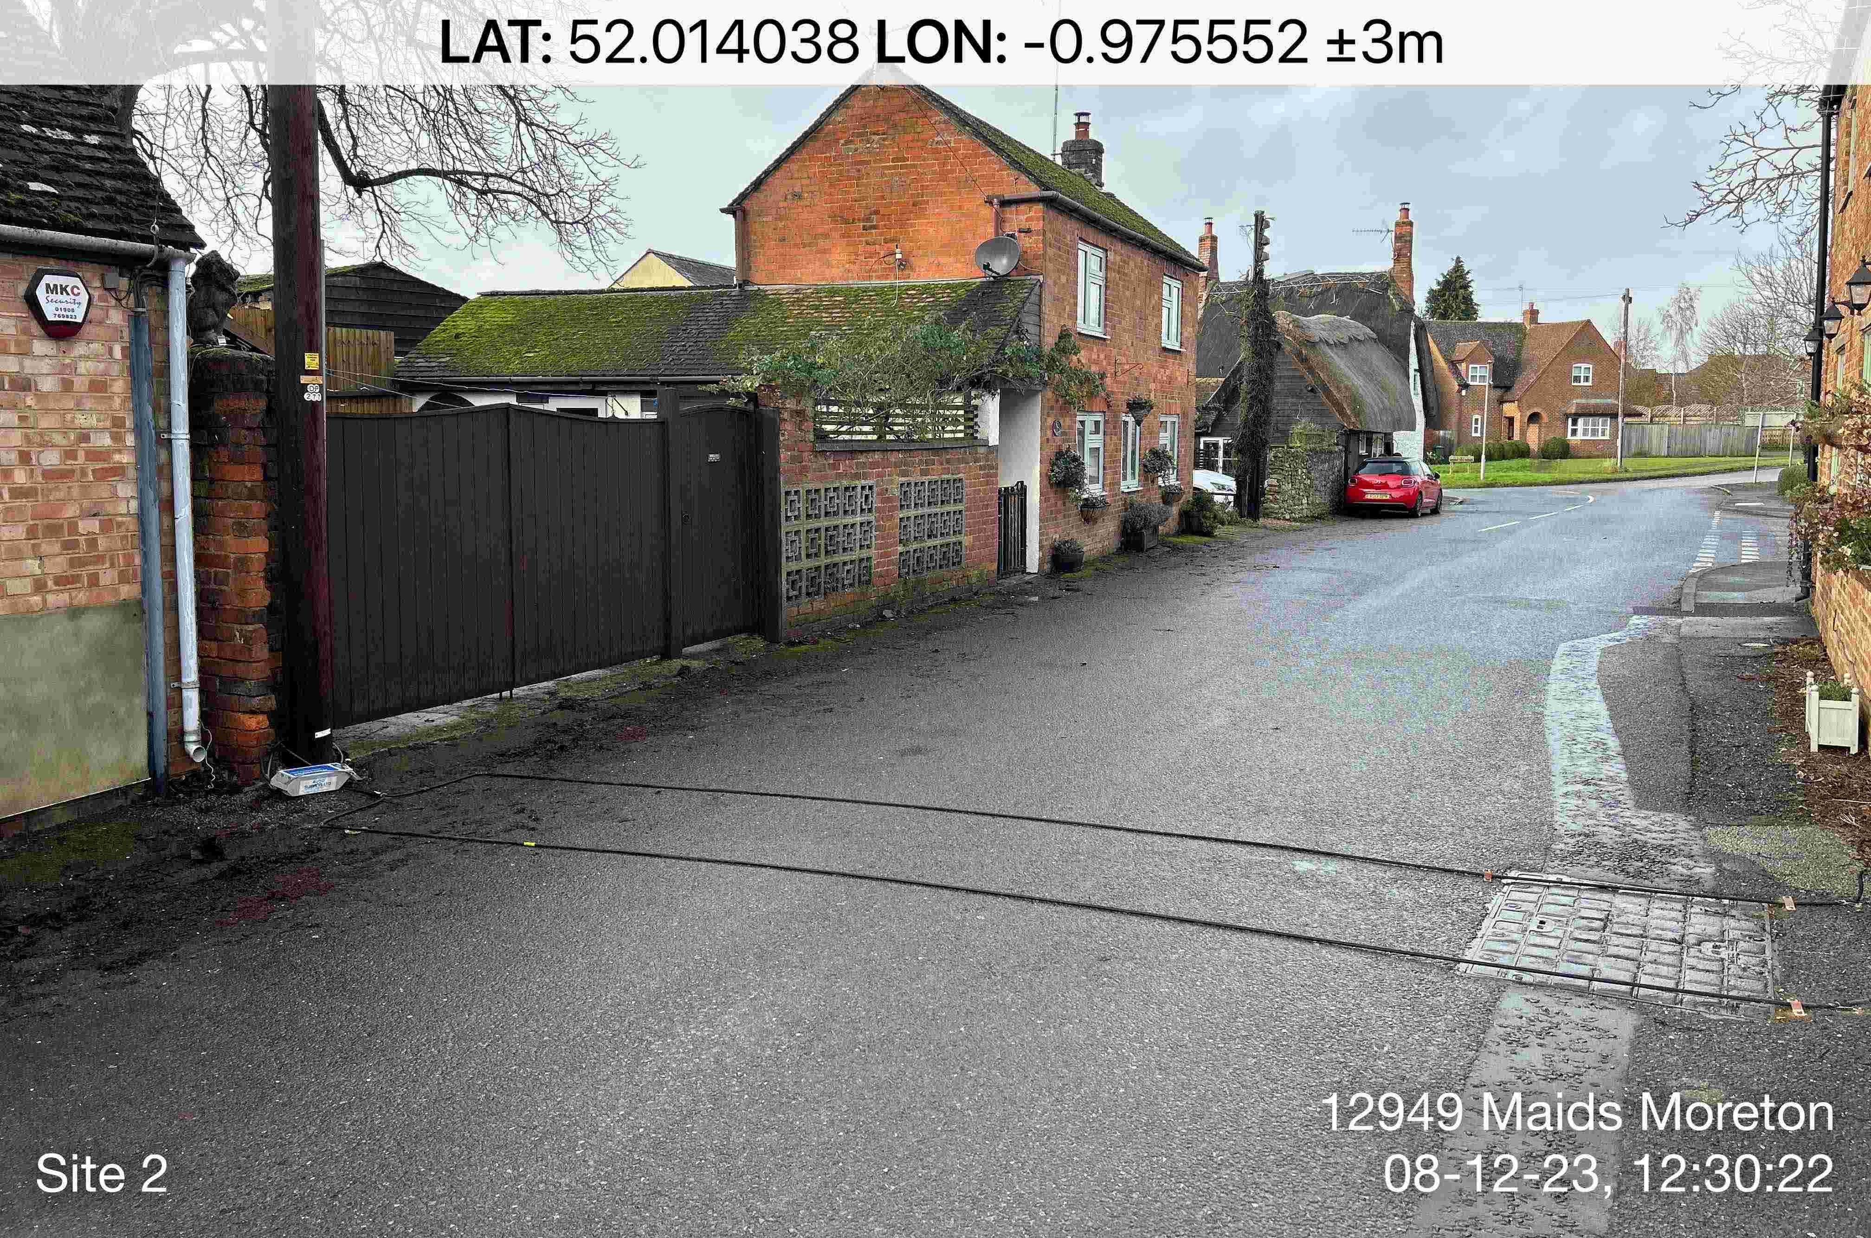

- Weekday and weekend speed – Main St
- Vehicle numbers in speed bands - weekdays

Start | 21-<26 mph |  | 26 -<31 mph |  | 31-<36 mph |  | 36-<41
hour | NB | SB | NB | SB | NB | SB | NB | SB
00.00 | 3 | 2 | 2 | 4 | 0 | 2 | 0 | 0
01.00 | 0 | 2 | 1 | 1 | 0 | 1 | 0 | 0
02.00 | 1 | 1 | 1 | 1 | 1 | 0 | 0 | 0
03.00 | 3 | 0 | 0 | 1 | 0 | 0 | 1 | 0
04.00 | 1 | 0 | 1 | 0 | 0 | 0 | 0 | 0
05.00 | 7 | 5 | 4 | 1 | 0 | 0 | 0 | 0
06.00 | 37 | 16 | 18 | 3 | 0 | 0 | 0 | 0
07.00 | 145 | 49 | 35 | 14 | 8 | 2 | 0 | 0
08.00 | 331 | 151 | 34 | 20 | 6 | 1 | 0 | 0
09.00 | 123 | 62 | 33 | 14 | 1 | 2 | 0 | 0
10.00 | 100 | 48 | 12 | 8 | 0 | 0 | 0 | 0
11.00 | 78 | 51 | 13 | 6 | 0 | 0 | 0 | 0
12.00 | 59 | 70 | 22 | 10 | 3 | 0 | 0 | 0
13.00 | 109 | 58 | 18 | 9 | 1 | 0 | 1 | 0
14.00 | 82 | 68 | 24 | 12 | 1 | 3 | 0 | 0
15.00 | 200 | 102 | 35 | 20 | 2 | 0 | 1 | 0
16.00 | 141 | 178 | 17 | 34 | 1 | 0 | 0 | 0
17.00 | 114 | 63 | 18 | 10 | 0 | 1 | 0 | 0
18.00 | 93 | 60 | 19 | 9 | 0 | 0 | 0 | 0
19.00 | 57 | 43 | 14 | 8 | 0 | 0 | 0 | 0
20.00 | 29 | 37 | 9 | 3 | 0 | 0 | 0 | 0
21.00 | 24 | 36 | 15 | 2 | 2 | 0 | 0 | 0
22.00 | 26 | 13 | 7 | 4 | 0 | 0 | 0 | 0
23.00 | 8 | 7 | 8 | 4 | 0 | 0 | 0 | 0
Total | 1771 | 1122 | 360 | 198 | 26 | 12 | 3 | 0

- Vehicle numbers in speed bands – weekends

Start | 21-<26 mph |  | 26 -<31 mph |  | 31-<36 mph |  | 36-<41
hour | NB | SB | NB | SB | NB | SB | NB | SB
00.00 | 5 | 3 | 2 | 0 | 0 | 0 | 0 | 0
01.00 | 0 | 1 | 0 | 1 | 1 | 0 | 0 | 0
02.00 | 0 | 2 | 0 | 3 | 0 | 0 | 0 | 0
03.00 | 1 | 0 | 1 | 0 | 0 | 0 | 0 | 0
04.00 | 0 | 0 | 0 | 0 | 0 | 0 | 0 | 0
05.00 | 1 | 0 | 0 | 0 | 0 | 0 | 0 | 0
06.00 | 3 | 2 | 4 | 0 | 0 | 0 | 0 | 0
07.00 | 17 | 9 | 3 | 1 | 0 | 0 | 0 | 0
08.00 | 19 | 8 | 6 | 2 | 0 | 0 | 0 | 0
09.00 | 36 | 19 | 15 | 2 | 0 | 0 | 0 | 0
10.00 | 29 | 24 | 4 | 6 | 2 | 0 | 0 | 0
11.00 | 40 | 29 | 5 | 6 | 0 | 0 | 0 | 0
12.00 | 49 | 24 | 9 | 4 | 2 | 0 | 0 | 0
13.00 | 36 | 25 | 9 | 2 | 0 | 1 | 0 | 0
14.00 | 32 | 31 | 13 | 5 | 0 | 0 | 0 | 0
15.00 | 21 | 22 | 4 | 2 | 0 | 0 | 0 | 0
16.00 | 15 | 17 | 4 | 4 | 0 | 0 | 0 | 0
17.00 | 33 | 19 | 4 | 6 | 2 | 0 | 0 | 0
18.00 | 18 | 11 | 3 | 3 | 1 | 0 | 0 | 0
19.00 | 13 | 15 | 8 | 0 | 0 | 0 | 0 | 0
20.00 | 15 | 12 | 6 | 2 | 1 | 0 | 0 | 0
21.00 | 5 | 5 | 4 | 2 | 3 | 0 | 0 | 0
22.00 | 9 | 6 | 3 | 2 | 0 | 0 | 0 | 0
23.00 | 3 | 3 | 2 | 1 | 0 | 0 | 0 | 0
Total | 400 | 287 | 109 | 54 | 12 | 1 | 0 | 0

- HGV detailed hourly flow on Main St and Walnut Drive
- HGVs Main St Northbound
Start hour | Sat 9 Dec | Sun 10 Dec | Mon 11 Dec | Tue 12 Dec | Wed 13 Dec | Thu 14 Dec | Fri 15 Dec | Total | Weekdays | Weekend
00.00 |  |  |  |  |  |  |  | 0 | 0 | 0
01.00 |  |  |  |  |  |  |  | 0 | 0 | 0
02.00 |  |  |  |  |  |  |  | 0 | 0 | 0
03.00 |  |  |  |  |  |  |  | 0 | 0 | 0
04.00 |  |  |  |  |  |  |  | 0 | 0 | 0
05.00 |  |  |  |  |  |  |  | 0 | 0 | 0
06.00 |  |  |  |  |  |  |  | 0 | 0 | 0
07.00 |  |  | 2 |  | 1 |  |  | 3 | 3 | 0
08.00 |  |  | 1 |  |  | 1 |  | 2 | 2 | 0
09.00 |  |  | 1 |  | 1 | 1 |  | 3 | 3 | 0
10.00 |  |  | 1 |  | 1 |  |  | 2 | 2 | 0
11.00 | 2 |  |  | 1 |  |  | 1 | 4 | 2 | 2
12.00 |  |  |  |  |  | 1 |  | 1 | 1 | 0
13.00 |  |  |  |  | 1 |  |  | 1 | 1 | 0
14.00 |  |  |  |  | 1 |  |  | 1 | 1 | 0
15.00 |  |  | 1 | 1 | 4 | 2 |  | 8 | 8 | 0
16.00 |  |  |  |  | 2 | 2 | 1 | 5 | 5 | 0
17.00 |  |  |  |  | 2 |  | 1 | 3 | 3 | 0
18.00 | 1 |  | 2 | 1 |  |  |  | 4 | 3 | 1
19.00 | 1 |  |  |  |  |  |  | 1 | 0 | 1
20.00 |  |  |  |  |  |  |  | 0 | 0 | 0
21.00 |  |  |  |  |  |  |  | 0 | 0 | 0
22.00 |  |  |  |  |  |  |  | 0 | 0 | 0
23.00 |  |  |  |  |  |  |  | 0 | 0 | 0
Total | 4 | 0 | 8 | 3 | 13 | 7 | 3 | 38 | 34 | 4
- HGVs Main St Southbound
Start hour | Sat 9 Dec | Sun 10 Dec | Mon 11 Dec | Tue 12 Dec | Wed 13 Dec | Thu 14 Dec | Fri 15 Dec | Total | Weekdays | Weekend
00.00 |  |  |  |  |  |  |  | 0 | 0 | 0
01.00 |  |  |  |  |  |  |  | 0 | 0 | 0
02.00 |  |  |  |  |  |  |  | 0 | 0 | 0
03.00 |  |  |  |  |  |  |  | 0 | 0 | 0
04.00 |  |  |  |  |  |  |  | 0 | 0 | 0
05.00 |  |  |  |  |  |  |  | 0 | 0 | 0
06.00 |  |  |  |  |  |  |  | 0 | 0 | 0
07.00 |  |  | 1 |  |  |  |  | 1 | 1 | 0
08.00 |  |  | 1 | 1 | 1 | 1 |  | 4 | 4 | 0
09.00 |  |  | 1 |  | 1 |  |  | 2 | 2 | 0
10.00 |  |  |  |  | 1 |  |  | 1 | 1 | 0
11.00 |  |  |  | 2 | 1 |  |  | 3 | 3 | 0
12.00 |  | 2 |  | 1 |  | 3 | 4 | 10 | 8 | 2
13.00 |  |  | 1 |  | 1 |  | 1 | 3 | 3 | 0
14.00 |  |  |  |  | 2 |  | 1 | 3 | 3 | 0
15.00 | 1 |  |  | 1 |  |  |  | 2 | 1 | 1
16.00 |  |  |  |  | 2 | 1 |  | 3 | 3 | 0
17.00 |  |  |  | 1 |  | 1 | 1 | 3 | 3 | 0
18.00 |  | 1 |  | 1 |  | 1 |  | 3 | 2 | 1
19.00 |  |  |  |  |  |  |  | 0 | 0 | 0
20.00 |  |  |  | 1 |  |  |  | 1 | 1 | 0
21.00 |  |  |  |  |  |  |  | 0 | 0 | 0
22.00 |  |  |  |  |  |  |  | 0 | 0 | 0
23.00 |  |  |  |  |  |  |  | 0 | 0 | 0
Total | 1 | 3 | 4 | 8 | 9 | 7 | 7 | 39 | 35 | 4

- HGVs Walnut Dr Eastbound
Start hour | Sat 9 Dec | Sun 10 Dec | Mon 11 Dec | Tue 12 Dec | Wed 13 Dec | Thu 14 Dec | Fri 15 Dec | Total | Weekdays | Weekend
00.00 |  |  |  |  |  |  |  | 0 | 0 | 0
01.00 |  |  | 1 | 1 |  |  |  | 2 | 2 | 0
02.00 |  |  |  |  |  |  |  | 0 | 0 | 0
03.00 |  |  |  |  |  |  |  | 0 | 0 | 0
04.00 |  |  |  |  |  |  |  | 0 | 0 | 0
05.00 |  |  |  |  |  |  |  | 0 | 0 | 0
06.00 |  |  | 1 |  | 1 |  |  | 2 | 2 | 0
07.00 |  |  | 1 | 1 |  |  |  | 2 | 2 | 0
08.00 |  |  | 2 | 5 | 6 | 3 |  | 16 | 16 | 0
09.00 |  |  | 2 | 2 | 1 |  |  | 5 | 5 | 0
10.00 |  | 1 | 1 |  | 1 | 1 | 1 | 5 | 4 | 1
11.00 | 1 | 1 | 2 |  |  |  | 1 | 5 | 3 | 2
12.00 |  |  |  | 4 | 2 | 2 |  | 8 | 8 | 0
13.00 |  |  | 1 |  | 2 | 3 | 1 | 7 | 7 | 0
14.00 |  |  |  | 2 |  |  |  | 2 | 2 | 0
15.00 |  |  | 1 |  |  |  |  | 1 | 1 | 0
16.00 |  |  |  |  |  |  | 2 | 2 | 2 | 0
17.00 |  |  |  | 2 |  |  | 1 | 3 | 3 | 0
18.00 | 1 |  |  |  | 1 |  |  | 2 | 1 | 1
19.00 |  |  |  |  | 1 |  |  | 1 | 1 | 0
20.00 |  |  |  |  |  |  |  | 0 | 0 | 0
21.00 |  |  |  |  |  |  |  | 0 | 0 | 0
22.00 |  |  |  |  |  |  |  | 0 | 0 | 0
23.00 |  |  |  |  |  |  |  | 0 | 0 | 0
Total | 2 | 2 | 12 | 17 | 15 | 9 | 6 | 63 | 59 | 4

- HGVs Walnut Dr Westbound
Start hour | Sat 9 Dec | Sun 10 Dec | Mon 11 Dec | Tue 12 Dec | Wed 13 Dec | Thu 14 Dec | Fri 15 Dec | Total | Weekdays | Weekend
00.00 |  |  |  |  |  |  |  | 0 | 0 | 0
01.00 | 1 |  |  |  |  |  |  | 1 | 0 | 1
02.00 |  |  |  |  |  |  | 1 | 1 | 1 | 0
03.00 |  |  |  |  |  |  |  | 0 | 0 | 0
04.00 |  |  |  |  |  |  |  | 0 | 0 | 0
05.00 |  |  |  |  |  |  |  | 0 | 0 | 0
06.00 |  |  |  | 1 | 1 |  |  | 2 | 2 | 0
07.00 |  |  | 2 |  | 1 |  |  | 3 | 3 | 0
08.00 | 1 |  | 1 |  |  |  |  | 2 | 1 | 1
09.00 | 1 |  |  | 1 |  |  |  | 2 | 1 | 1
10.00 |  | 1 | 2 |  |  | 1 | 2 | 6 | 5 | 1
11.00 |  |  | 1 |  |  | 1 |  | 2 | 2 | 0
12.00 | 1 |  | 2 | 3 |  | 1 | 2 | 9 | 8 | 1
13.00 |  |  | 1 | 4 |  |  | 1 | 6 | 6 | 0
14.00 | 1 |  | 1 |  |  | 1 |  | 3 | 2 | 1
15.00 |  | 1 |  | 1 |  | 1 |  | 3 | 2 | 1
16.00 |  |  |  |  |  | 2 | 4 | 6 | 6 | 0
17.00 |  |  | 4 | 2 | 2 | 4 | 1 | 13 | 13 | 0
18.00 |  |  |  | 1 | 1 | 1 | 1 | 4 | 4 | 0
19.00 |  |  |  | 1 |  |  |  | 1 | 1 | 0
20.00 |  |  |  |  |  |  | 1 | 1 | 1 | 0
21.00 |  |  |  |  |  | 1 |  | 1 | 1 | 0
22.00 |  |  |  |  |  |  |  | 0 | 0 | 0
23.00 |  |  |  |  |  |  |  | 0 | 0 | 0
Total | 5 | 2 | 14 | 14 | 5 | 13 | 13 | 66 | 59 | 7

School holidays
ATC Main St
ATC Main St – school holidays
Average weekday figure

